Circuit Analysis
Lab 10
Assignment

Submitted by:
Wardah Shahid
2025-CE-81

University of Engineering
and Technology

Circuit(I_L):
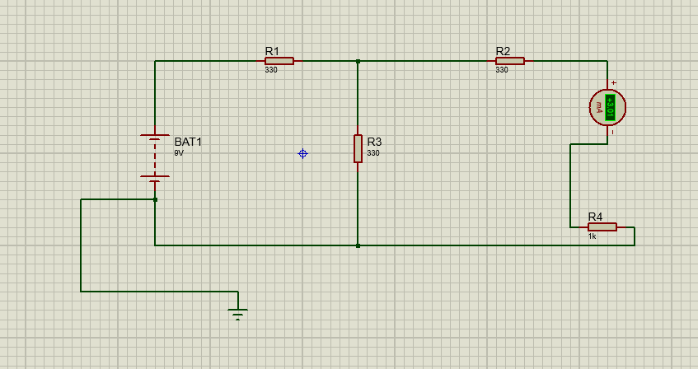

Explanation:
· Objective: To measure the actual current flowing through the load resistor in the original network.
· Process: The circuit is constructed with the power supply (RPS), three 330 resistors, and a 1k load resistor.
· Measurement: A DC ammeter is connected in series with the 1k load resistor.
· Result: The reading obtained from the ammeter is recorded as the original load current (I_L).
Circuit(V_TH):
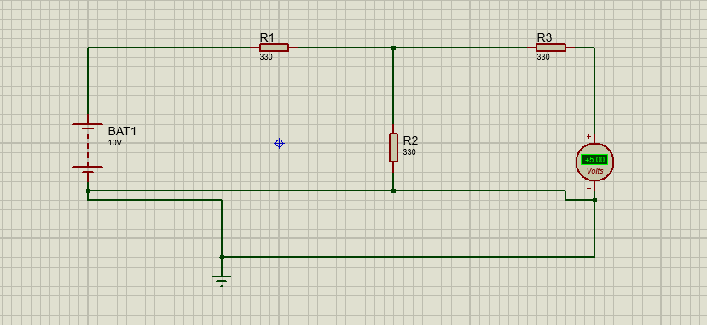

Explanation:
· Objective: To determine the open-circuit voltage across the load terminals.
· Process: The load resistor 1k and the ammeter are removed from the circuit, leaving terminals A and B open.
· Measurement: A voltmeter is connected across these open terminals while the power supply is still active.
· Result: The voltage measured by the voltmeter is the Thevenin’s Equivalent Voltage (V_TH)
Circuit (Thevenin’s Equivalent):

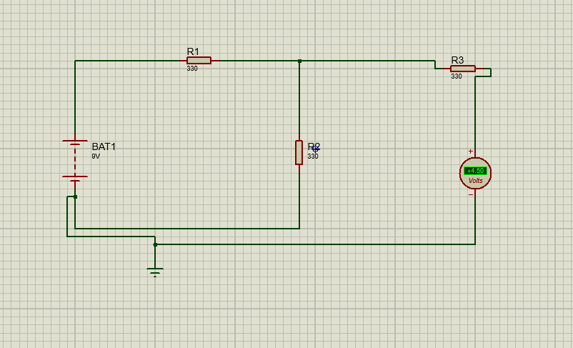

Explanation:
• Objective: To simplify the complex network into a single source and a single resistor to verify the theorem.
- · Process: A new circuit is built using the calculated V_{TH} as the voltage source and R_{TH} as a series resistor.
- · Measurement: The original 1k load resistor and the ammeter are reconnected to this simplified series circuit.
· Verification: The current reading on the ammeter is compared with the current from "Circuit - 1." If they are equal, the theorem is verified.

Table:
